#
# 20200625
# I tried to add into freeipa one server, that was added into freeipa before. And I received errors on last task in Selin’s playbook.
# Pavel Selin advised me to update my repository copy.
# But because he modified it significantly, to make it works again at this moment needs to run one addition command - receive requirements.
# I did it and the playbook became working again.
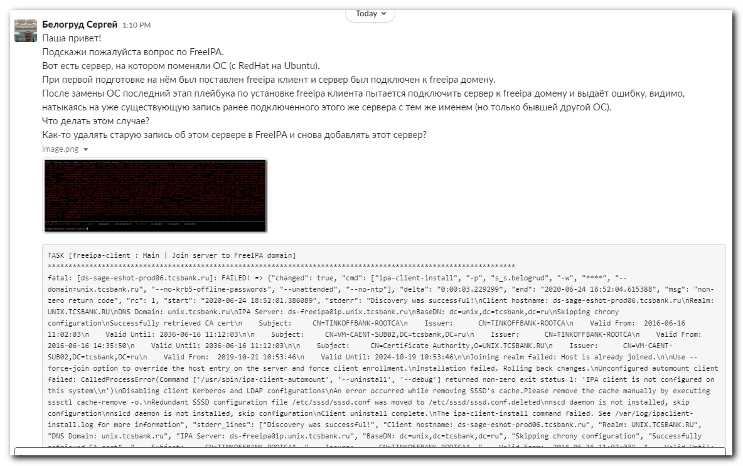
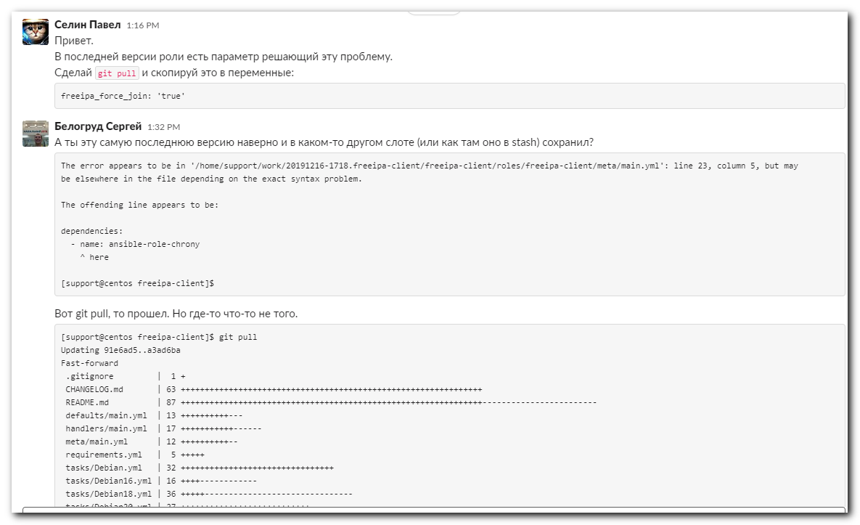
Селин Павел 1:16 PM
Привет.
В последней версии роли есть параметр решающий эту проблему.
Сделай git pull и скопируй это в переменные:
freeipa_force_join: 'true'
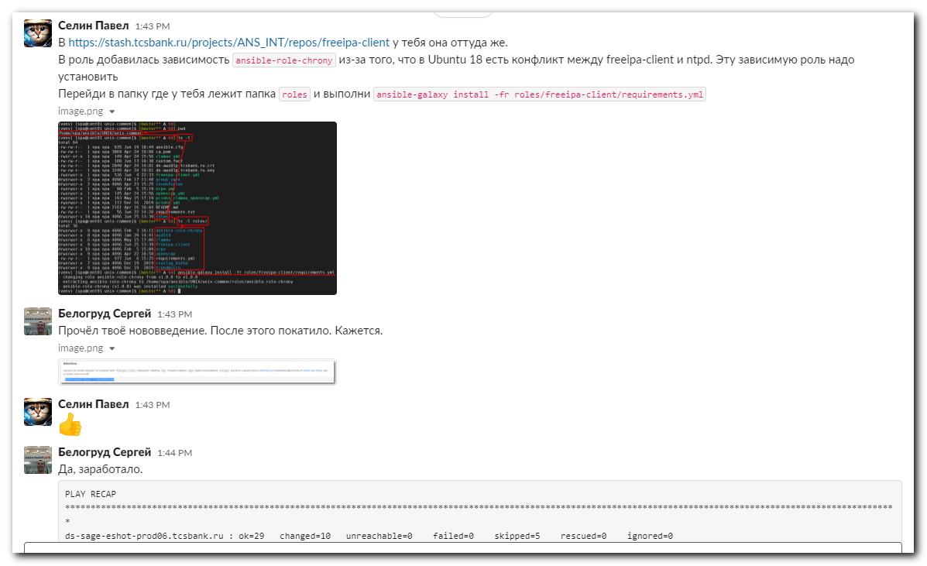
Селин Павел 1:43 PM
В https://stash.tcsbank.ru/projects/ANS_INT/repos/freeipa-client у тебя она оттуда же.
В роль добавилась зависимость ansible-role-chrony из-за того, что в Ubuntu 18 есть конфликт между freeipa-client и ntpd. Эту зависимую роль надо установить
Перейди в папку где у тебя лежит папка roles и выполни ansible-galaxy install -fr roles/freeipa-client/requirements.yml
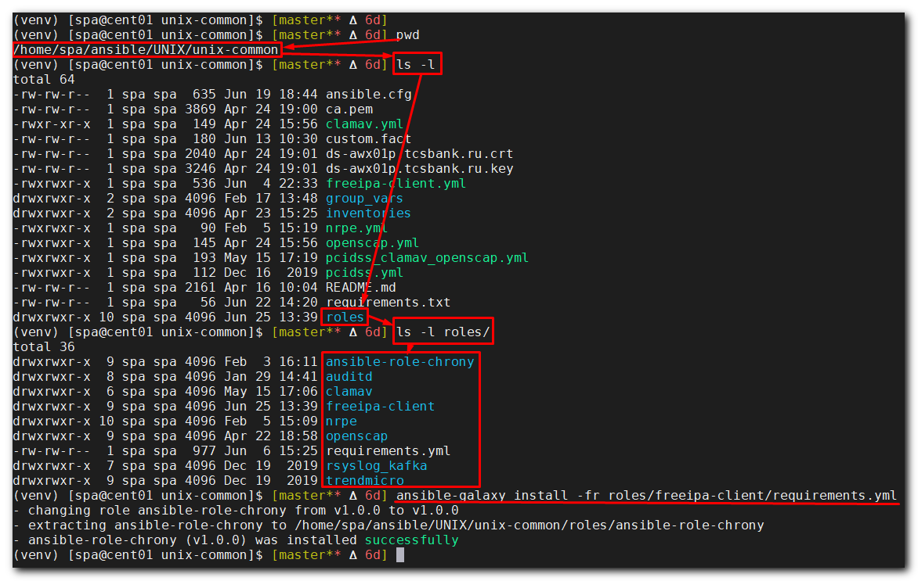

[support@centos freeipa-client]$ ansible-playbook 20191216-1721.install.freeipa-client.yml -i list_of_hosts --become --extra-vars "ansible_user=bsv ansible_password=$(pass common/linux) ansible_sudo_pass=$(pass common/linux) ansible_ssh_common_args='-oStrictHostKeyChecking=no -oPubkeyAuthentication=no -oUserKnownHostsFile=/dev/null'"
...
TASK [freeipa-client : Main | Join server to FreeIPA domain] *****************************************************************************************************************
fatal: [ds-sage-eshot-prod06.tcsbank.ru]: FAILED! => {"changed": true, "cmd": ["ipa-client-install", "-p", "s_s.belogrud", "-w", "****", "--domain=unix.tcsbank.ru", "--no-krb5-offline-passwords", "--unattended", "--no-ntp"], "delta": "0:00:03.229299", "end": "2020-06-24 18:52:04.615388", "msg": "non-zero return code", "rc": 1, "start": "2020-06-24 18:52:01.386089", "stderr": "Discovery was successful!\nClient hostname: ds-sage-eshot-prod06.tcsbank.ru\nRealm: UNIX.TCSBANK.RU\nDNS Domain: unix.tcsbank.ru\nIPA Server: ds-freeipa01p.unix.tcsbank.ru\nBaseDN: dc=unix,dc=tcsbank,dc=ru\nSkipping chrony configuration\nSuccessfully retrieved CA cert\n Subject: CN=TINKOFFBANK-ROOTCA\n Issuer: CN=TINKOFFBANK-ROOTCA\n Valid From: 2016-06-16 11:02:03\n Valid Until: 2036-06-16 11:12:03\n\n Subject: CN=VM-CAENT-SUB02,DC=tcsbank,DC=ru\n Issuer: CN=TINKOFFBANK-ROOTCA\n Valid From: 2016-06-16 14:35:50\n Valid Until: 2036-06-16 11:12:03\n\n Subject: CN=Certificate Authority,O=UNIX.TCSBANK.RU\n Issuer: CN=VM-CAENT-SUB02,DC=tcsbank,DC=ru\n Valid From: 2019-10-21 10:53:46\n Valid Until: 2024-10-19 10:53:46\n\nJoining realm failed: Host is already joined.\n\nUse --force-join option to override the host entry on the server and force client enrollment.\nInstallation failed. Rolling back changes.\nUnconfigured automount client failed: CalledProcessError(Command ['/usr/sbin/ipa-client-automount', '--uninstall', '--debug'] returned non-zero exit status 1: 'IPA client is not configured on this system\\n')\nDisabling client Kerberos and LDAP configurations\nAn error occurred while removing SSSD's cache.Please remove the cache manually by executing sssctl cache-remove -o.\nRedundant SSSD configuration file /etc/sssd/sssd.conf was moved to /etc/sssd/sssd.conf.deleted\nnscd daemon is not installed, skip configuration\nnslcd daemon is not installed, skip configuration\nClient uninstall complete.\nThe ipa-client-install command failed. See /var/log/ipaclient-install.log for more information", "stderr_lines": ["Discovery was successful!", "Client hostname: ds-sage-eshot-prod06.tcsbank.ru", "Realm: UNIX.TCSBANK.RU", "DNS Domain: unix.tcsbank.ru", "IPA Server: ds-freeipa01p.unix.tcsbank.ru", "BaseDN: dc=unix,dc=tcsbank,dc=ru", "Skipping chrony configuration", "Successfully retrieved CA cert", " Subject: CN=TINKOFFBANK-ROOTCA", " Issuer: CN=TINKOFFBANK-ROOTCA", " Valid From: 2016-06-16 11:02:03", " Valid Until: 2036-06-16 11:12:03", "", " Subject: CN=VM-CAENT-SUB02,DC=tcsbank,DC=ru", " Issuer: CN=TINKOFFBANK-ROOTCA", " Valid From: 2016-06-16 14:35:50", " Valid Until: 2036-06-16 11:12:03", "", " Subject: CN=Certificate Authority,O=UNIX.TCSBANK.RU", " Issuer: CN=VM-CAENT-SUB02,DC=tcsbank,DC=ru", " Valid From: 2019-10-21 10:53:46", " Valid Until: 2024-10-19 10:53:46", "", "Joining realm failed: Host is already joined.", "", "Use --force-join option to override the host entry on the server and force client enrollment.", "Installation failed. Rolling back changes.", "Unconfigured automount client failed: CalledProcessError(Command ['/usr/sbin/ipa-client-automount', '--uninstall', '--debug'] returned non-zero exit status 1: 'IPA client is not configured on this system\\n')", "Disabling client Kerberos and LDAP configurations", "An error occurred while removing SSSD's cache.Please remove the cache manually by executing sssctl cache-remove -o.", "Redundant SSSD configuration file /etc/sssd/sssd.conf was moved to /etc/sssd/sssd.conf.deleted", "nscd daemon is not installed, skip configuration", "nslcd daemon is not installed, skip configuration", "Client uninstall complete.", "The ipa-client-install command failed. See /var/log/ipaclient-install.log for more information"], "stdout": "", "stdout_lines": []}

PLAY RECAP *******************************************************************************************************************************************************************
ds-sage-eshot-prod06.tcsbank.ru : ok=11 changed=0 unreachable=0 failed=1 skipped=0 rescued=0 ignored=0

[support@centos freeipa-client]$

[support@centos freeipa-client]$ cd roles/freeipa-client/
[support@centos freeipa-client]$ git pull
Updating 91e6ad5..a3ad6ba
error: Your local changes to the following files would be overwritten by merge:
tasks/main.yml
vars/main.yml
Please, commit your changes or stash them before you can merge.
Aborting
[support@centos freeipa-client]$ mkdir ../../backup
[support@centos freeipa-client]$ cp vars/main.yml ../../backup/
[support@centos freeipa-client]$

[support@centos freeipa-client]$ git checkout tasks/main.yml
[support@centos freeipa-client]$ git checkout vars/main.yml

[support@centos freeipa-client]$ git pull
Updating 91e6ad5..a3ad6ba
Fast-forward
.gitignore | 1 +
CHANGELOG.md | 63 +++++++++++++++++++++++++++++++++++++++++++++++++++++++++++++++
README.md | 87 +++++++++++++++++++++++++++++++++++++++++++++++++++++++++++++++------------------------
defaults/main.yml | 13 ++++++++++---
handlers/main.yml | 17 +++++++++++------
meta/main.yml | 12 ++++++++++--
requirements.yml | 5 +++++
tasks/Debian.yml | 32 ++++++++++++++++++++++++++++++++
tasks/Debian16.yml | 16 ++++------------
tasks/Debian18.yml | 36 +++++-------------------------------
tasks/Debian20.yml | 27 +++++++++++++++++++++++++++
tasks/main.yml | 73 ++++++++++++++++++++++++++++++++++++++++++++++---------------------------
vars/main.yml | 20 --------------------
13 files changed, 277 insertions(+), 125 deletions(-)
create mode 100644 CHANGELOG.md
create mode 100644 requirements.yml
create mode 100644 tasks/Debian20.yml
[support@centos freeipa-client]$

[support@centos freeipa-client]$ vim -O ../../backup/main.yml vars/main.yml
[support@centos freeipa-client]$ cat vars/main.yml
20191216-1721.install.freeipa-client.yml list_of_hosts .yamllint
backup/ roles/
[support@centos freeipa-client]$ cat roles/freeipa-client/vars/main.yml
---
repo:
Debian:
name: "sssd"
url: "deb http://repo-linux.tcsbank.ru/sssd/deb/1.15/ /"
key: "http://repo-linux.tcsbank.ru/sssd/deb/1.15/debian-repo-public.gpg"
desc: "SSSD 1.15 repository"
RedHat:
name: "sssd"
url: "http://repo-linux.tcsbank.ru/sssd/rpm/el6"
key: "http://repo-linux.tcsbank.ru/sssd/deb/1.15/debian-repo-public.gpg"
desc: "SSSD 1.15 repository"

ipajoin: {user: 's_s.belogrud', pass: '****'}
freeipa_force_join: 'true'

[support@centos freeipa-client]$

[support@centos freeipa-client]$ ansible-playbook 20191216-1721.install.freeipa-client.yml -i list_of_hosts --become --extra-vars "ansible_user=bsv ansible_password=$(pass common/linux) ansible_sudo_pass=$(pass common/linux) ansible_ssh_common_args='-oStrictHostKeyChecking=no -oPubkeyAuthentication=no -oUserKnownHostsFile=/dev/null'"
ERROR! the role 'ansible-role-chrony' was not found in /home/support/work/20191216-1718.freeipa-client/freeipa-client/roles:/home/support/.ansible/roles:/usr/share/ansible/roles:/etc/ansible/roles:/home/support/work/20191216-1718.freeipa-client/freeipa-client/roles:/home/support/work/20191216-1718.freeipa-client/freeipa-client

The error appears to be in '/home/support/work/20191216-1718.freeipa-client/freeipa-client/roles/freeipa-client/meta/main.yml': line 23, column 5, but may
be elsewhere in the file depending on the exact syntax problem.

The offending line appears to be:

dependencies:
- name: ansible-role-chrony
^ here

[support@centos freeipa-client]$

#
# The solution was found here. And after I found it, Pavel repeat it in his message in the Slack.
# https://stash.tcsbank.ru/projects/ANS_INT/repos/freeipa-client/browse
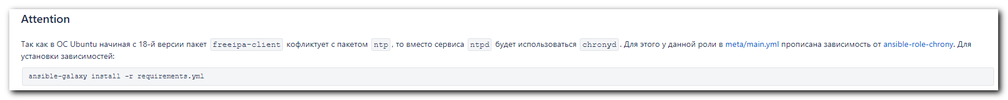

[support@centos freeipa-client]$ ansible-galaxy install -r requirements.yml
- extracting ansible-role-chrony to /home/support/.ansible/roles/ansible-role-chrony
- ansible-role-chrony (v1.0.0) was installed successfully
[support@centos freeipa-client]$

# After this, the playbook started to work again.
#

# 20191216
#

# Обязательные пункты подготовки (check list)
# https://wiki.tcsbank.ru/pages/viewpage.action?pageId=577581494

#
# To use stash repository freeipa-clinet.
# https://stash.tcsbank.ru/projects/ANS_INT/repos/freeipa-client/browse
#

#
# The first of all, we have to clone repository.
#
[support@centos freeipa-client]$ cat ../readme.txt
[support@centos 20191216-1718.freeipa-client]$ git clone https://stash.tcsbank.ru/scm/ans_int/freeipa-client.git
Cloning into 'freeipa-client'...
remote: Counting objects: 224, done.
remote: Compressing objects: 100% (162/162), done.
remote: Total 224 (delta 98), reused 101 (delta 36)
Receiving objects: 100% (224/224), 34.29 KiB | 0 bytes/s, done.
Resolving deltas: 100% (98/98), done.
[support@centos 20191216-1718.freeipa-client]$
[support@centos freeipa-client]$

#
# It have to be created directory "roles" and there need place cloned repository.
# Directory tree looks like below.
#
[support@centos freeipa-client]$ tree /home/support/work/20191216-1718.freeipa-client/freeipa-client
/home/support/work/20191216-1718.freeipa-client/freeipa-client
├── 20191216-1721.install.freeipa-client.yml
├── list_of_hosts
└── roles
└── freeipa-client
├── defaults
│ └── main.yml
├── handlers
│ └── main.yml
├── meta
│ └── main.yml
├── molecule
│ └── default
│ ├── cleanup.yml
│ ├── Dockerfile.j2
│ ├── INSTALL.rst
│ ├── molecule.yml
│ ├── playbook.yml
│ ├── prepare.yml
│ ├── tests
│ │ └── test_default.py
│ └── uninstall.yml
├── netbox.crt
├── netbox_recent.py
├── README.md
├── tasks
│ ├── Debian16.yml
│ ├── Debian18.yml
│ ├── Debian.yml
│ ├── main.yml
│ └── RedHat6.yml
├── templates
│ ├── krb5.conf.j2
│ └── sssd.conf.j2
└── vars
└── main.yml

11 directories, 24 files
[support@centos freeipa-client]$

#
# This variable was generated and sent to us by Selin Pavel, when he enroll freeipa to use.
# I've saved it in KeePass.
#
[support@centos freeipa-client]$ tail -n 3 roles/freeipa-client/vars/main.yml

ipajoin: {user: 's_s.belogrud', pass: '*****'}

[support@centos freeipa-client]$

[support@centos freeipa-client]$ ansible-playbook 20191216-1721.install.freeipa-client.yml -i list_of_hosts --become --extra-vars "ansible_user=bsv ansible_password=$(pass common/linux) ansible_sudo_pass=$(pass common/linux) ansible_ssh_common_args='-oStrictHostKeyChecking=no -oPubkeyAuthentication=no'"

PLAY [all] ************************************************************************************************************************************************************************************************

TASK [Gathering Facts] ************************************************************************************************************************************************************************************
ok: [m1-datagrid01p]

TASK [freeipa-client : Main | Check ds-freeipa01p.unix.tcsbank.ru:636 ldap-ssl connectivity] **************************************************************************************************************
ok: [m1-datagrid01p]

TASK [freeipa-client : Main | Include OS specific tasks] **************************************************************************************************************************************************
[DEPRECATION WARNING]: Use errors="ignore" instead of skip. This feature will be removed in version 2.12. Deprecation warnings can be disabled by setting deprecation_warnings=False in ansible.cfg.

TASK [freeipa-client : Main | Install ipa-client] *********************************************************************************************************************************************************
ok: [m1-datagrid01p] => (item={u'state': u'present', u'name': u'ipa-client'})

TASK [freeipa-client : Main | Join server to FreeIPA domain] **********************************************************************************************************************************************
changed: [m1-datagrid01p]

TASK [freeipa-client : Main | Create krb5.conf.d directory] ***********************************************************************************************************************************************
ok: [m1-datagrid01p]

TASK [freeipa-client : Main | Deploy KRB5 config] *********************************************************************************************************************************************************
changed: [m1-datagrid01p]

TASK [freeipa-client : Main | Deploy SSSD config] *********************************************************************************************************************************************************
changed: [m1-datagrid01p]

TASK [freeipa-client : Main | Enable pam mkhomedir] *******************************************************************************************************************************************************
changed: [m1-datagrid01p] => (item=system-auth)
changed: [m1-datagrid01p] => (item=password-auth)

TASK [freeipa-client : Main | Update sshd_config] *********************************************************************************************************************************************************
changed: [m1-datagrid01p] => (item={u'regexp': u'^#?\\s*ChallengeResponseAuthentication', u'line': u'ChallengeResponseAuthentication no'})

TASK [freeipa-client : Configure | Login to ipa server] ***************************************************************************************************************************************************
skipping: [m1-datagrid01p]

TASK [freeipa-client : Configure | Ensure hostgroup created] **********************************************************************************************************************************************
skipping: [m1-datagrid01p]

TASK [freeipa-client : Configure | Adding host to hostgroup] **********************************************************************************************************************************************
skipping: [m1-datagrid01p]

RUNNING HANDLER [freeipa-client : restart sssd] ***********************************************************************************************************************************************************
changed: [m1-datagrid01p]

RUNNING HANDLER [freeipa-client : restart sshd] ***********************************************************************************************************************************************************
changed: [m1-datagrid01p]

RUNNING HANDLER [freeipa-client : restart nscd] ***********************************************************************************************************************************************************
skipping: [m1-datagrid01p]

PLAY RECAP ************************************************************************************************************************************************************************************************
m1-datagrid01p : ok=11 changed=7 unreachable=0 failed=0 skipped=5 rescued=0 ignored=0

[support@centos freeipa-client]$

[root@m1-datagrid01p ~]# tail -n 5 /var/log/ipaclient-install.log

2019-12-16T14:43:34Z DEBUG stderr=
2019-12-16T14:43:34Z DEBUG Restart of rhel-domainname.service complete
2019-12-16T14:43:34Z INFO Client configuration complete.
2019-12-16T14:43:34Z INFO The ipa-client-install command was successful
[root@m1-datagrid01p ~]#

#
# To install freeipa client correctly, it’s require to have FQDN for the target server.
#
[root@m1-datagrid01p ~]# hostname -f
m1-datagrid01p.tcsbank.ru
[root@m1-datagrid01p ~]#

#
# If not defined variables "ipajoin", follow errors appear at the end of log file.
#
[root@m1-datagrid01p ~]# less /var/log/ipaclient-install.log
...
2019-12-16T14:35:57Z DEBUG The ipa-client-install command failed, exception: ScriptError: Kerberos authentication failed: kinit: Client 'user@UNIX.TCSBANK.RU' not found in Kerberos database while getting initial credentials
...
# Instead of “user”, require special user name.

